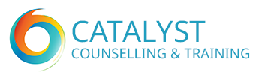
Training Programme


44 Alexandra Road
Lowestoft
Suffolk Academic Year Beginning 2023
NR32 1PJ

Tel: 01502 516957

Email: training@catalyst-wcs.org.uk
Catalyst Counselling CIC: Co. Number: 08894088

BACP No: 101953 UK Learning Provider Reference No:10058037

Course Accreditation by British Psychoanalytic Council Pending

What people who have trained with us have said
“Training was a fantastic, challenging, healing and awakening process. The whole experience within the centre enabled me to gain confidence, and support others in doing the same. Further to this, and outside the centre, my training has been recognised and enabled me to build a career with psychodynamic skills, as a recognised and respected foundation”

“I am on a journey of becoming, a new person—more capable than before of relating to others more deeply, more satisfyingly.
This training course empowered me on my journey”

“This training is, simply, one of the best things I have ever done, in my life. I feel so fortunate to have come across a training in the psychodynamic model, as I feel that it was definitely the right way forward for me, and provided me with a very strong basis to develop myself towards becoming a professional psychotherapist.”

“Without CATALYST psychodynamic training, supervision and my own counselling, I wouldn’t be where I am today. CATALYST has changed my life for the better and provided me with an in-depth awareness of who I am and what I can achieve in my life. My confidence and self-esteem have grown immensely”.

“CATALYST created a very safe environment for me to develop my skills and understanding. If you’re serious about becoming a counsellor or developing your counselling skills, I’d highly recommend training with CATALYST”
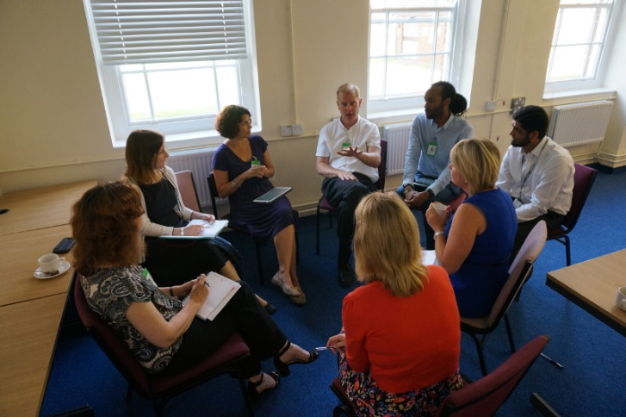

CATALYST Counselling Training Courses
Contents:
About CATALYST P.4
The Psychodynamic Model P.4
Why train with CATALYST? P.5
Our Training Programmes P.6
After Training P.6

Introduction to Counselling Skills P.7

Certificate in Psychodynamic Counselling Skills P.7/8
Clinical Diploma in Psychodynamic Counselling P.9/10
Assessment Requirements P.11
Diploma in Psychodynamic Theory – Non-Clinical Route P.12



About Catalyst Counselling CIC

CATALYST Counselling was established, as Waveney Counselling Service—a community counselling and training agency, in 1990. In 2013 it ceased trading as a charity, and has since achieved recognition as a social enterprise, or Community Interest Company (CIC).
We provide affordable, high-quality counselling and psychotherapy, which is open to all members of the population of the coastal area from villages north of Great Yarmouth, through to Lowestoft, Southwold, Beccles and surrounding areas.
Counselling provides a regular time and space for people to talk about their problems and explore difficult feelings in an environment that is dependable, private and confidential. Some people come to counselling because of difficult experiences such as bereavement, redundancy or other losses; these specific issues can often be resolved in a relatively short period of time. Other people come for help with problems such as depression, anxiety, low self-esteem, abuse or anger. It can take longer to work through some of these issues, the roots of which often lie in childhood.
The Psychodynamic model
Unusually for this geographical area, CATALYST trains and works to the psychodynamic model. This model works with the underlying structures, in the personality which limit the person’s ability to enjoy life and fulfil their potential. The counsellor sensitively and carefully works with the client to clarify these limiting dynamics, moving towards a more comfortable way of being.
Psychodynamic counselling has in common with person-centred counselling a respect for the client, using skills of empathy, reflecting back, clarification and paraphrasing to help the client unfold and understand their difficulties in detail.
As well as emphasising the potential of the relationship between counsellor and client to help the client heal other relationships, the psychodynamic model also explores the links between past and present relationships. Within the counselling, these patterns from the past re-emerge. In the present, they can then be thought about, understood, and a new resolution found.
Another distinguishing factor between this and other models is the work with the interplay between the conscious and unconscious systems. The task of the counsellor is to help the client bring the feelings from the unconscious world into conscious awareness, sufficiently to be able to check them against current external reality, and make changes.
Core aspects of the work include:
• Addressing avoidance defences
• Exploring emotions
• Focussing on the therapy relationship
• Identifying recurring themes
• Differentiating past from present
Why train with CATALYST?
CATALYST Counselling has a widely respected reputation as a counselling and training provider. We are a leading provider of counselling to the local community, both for clients who self-refer and through our contracts with other organisations.
Our aim is always to train counsellors to the best possible level of competence and professionalism, to ensure that they will be qualified for and capable of working in any setting.
We believe that, as a Centre, we offer a unique opportunity in this area:
• An assurance that the quality of all of our services is constantly monitored and appraised
• Since we are a counselling service, working in our local community, trainees do not have to go elsewhere to seek placements for their clinical work, or to find supervisors. This factor, is unique in this area, and, in itself, removes a significant source of stress, and cost, from the training process.
• The fact that clinical practice and supervision are included in the package enables our trainees to acquire a wider ranging experience than would otherwise be likely. The level of clinical work is monitored and closely matched to suit the development of each trainee. We believe this best equips our trainees, ultimately to work as professional counsellors in the outside world, as well as ensuring the quality of the service for clients.
• The centre offers trainees a sense of belonging, and a progressive career structure, with further opportunities for paid clinical work, advanced training and continuing professional development, for those who are interested, post qualification. We would suggest that training can never finish, as such, if we are to keep on developing as practitioners and people, and for the best interests of our clients. This point is reflected in the on-going modular programme of further professional development workshops.
• Support is available for those in process of applying for Registration and individual Accreditation with BACP.
CATALYST Counselling Centre grew out of the Westminster Pastoral Foundation Network, by whom we were accredited until the Network was dissolved in 2013.
We are committed to maintaining the standards of excellence in counselling and training, which have always been the basic ethos of this organisation.
Our standards of professional practice are constantly monitored and appraised.
We aim to provide a high-quality service and continually monitor, appraise and evaluate our performance at all levels, including feedback from clients, trainees and referrers.
CATALYST is also a member of the British Association of Counselling and Psychotherapy (BACP No: 101953) and we work to their Ethical Framework of Good Practice.

CATALYST Counselling Training Courses
All tutors have extensive experience in counselling and training, and have additional training/accreditation in teaching. We have a maximum number of 10 trainees per group.
We provide integrated programmes of training which include
- An Introduction to Counselling – A six session course
- Certificate in Psychodynamic Counselling Skills—a one-year course
This course can be taken as a stand—alone course; it is also an entry level for the:
• Clinical Diploma in Psychodynamic Counselling—a further two year + 1 term course
After qualification:
• Assessment and Time-limited Counselling Training
• Advanced Psychodynamic Theory and Clinical Practice
• An In house Programme of CPD workshops, also open to other professionals
All of these are provided with the aim of supporting counsellors in their development of a portfolio and a career path towards application for individual accreditation, and work as a professional counsellor.
Our training team and supervisors are experienced counsellors and psychotherapists.
We have a vested interest in helping you become the best counsellor that you can be, in terms of maintaining our high standards of work in the Centre.
After Training
Once training has been completed at Clinical Diploma level, counsellors are eligible to apply to work as Counsellors within the centre and towards gaining individual accreditation. Many of our trainees and counsellors explain that being a member of a working Centre provides them with a sense of community and belonging. There is a shared sense of purpose in the work of the Centre as a Social Enterprise. This all helps to make the learning experience, and the work, more enjoyable.

LEVEL ONE An Introduction to Counselling Skills
Evening Training Programme – next course dates to be decided for June 2023 - 12 hours
In total. Monday or Thursday evenings from 7.00pm until 9.15 pm. Further courses to follow.
Cost £130.00. For further details contact the Training Director.
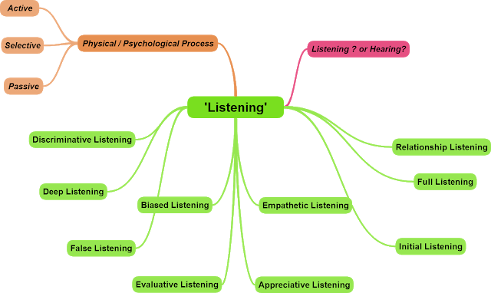

LEVEL TWO Certificate in Psychodynamic Counselling Skills
Weekend / evening training Programme beginning October 2023 – 180 hours in total:
105 hours seminars/skills training
45 hours self-development group work
30 hours guided learning

These will take place on second weekend of every month from October 2023—July 2024,
and one evening a week for 1 ½ hours each week over 30 weeks; day and start time to be advised.

Plus 3 Saturday workshops—5 hours each day (10.00 am until 4.00pm)
Weekend training days run from 10.00 am to 3.30 pm

Selection Criteria: Personal and emotional potential for exploring psychodynamic issues and counselling skills. Evidence of intellectual potential to complete the theoretical elements of the course, and the written assignments.
Aims: By the end of the course students will have developed the basic skills and knowledge outlined below, under Content.
Students will be able to recognise patterns in behaviour within themselves and others.
Students will have a working understanding of basic theory about human growth and development.
Students will have developed a working knowledge and practice of counselling skills
Students will have an awareness of working and living in a multicultural society where differences are acknowledged and worked with sensitively.

Content:
- Active listening, paraphrasing and reflecting back
- Basic theory of empathy, genuineness, respect
- The importance of boundaries and trust in counselling
- Stages of human and psychosocial development
- Basic Psychodynamic Counselling Theory
- Linking developmental issues to counselling
- Experiential group for self-development
- Understanding the difference between counselling and helping
- Understanding ethical issues and the BPC/BACP Ethical Framework

Venue: CATALYST Counselling, 44 Alexandra Road, Lowestoft
Fees: £2,300, which includes workshop fees (payment options are available) Fees are usually paid in 3 x termly instalments or 10 x monthly instalments – there will be a small fee chargeable for the latter.
For further details, or to ascertain how other courses you have completed may link in with the training, contact the Director of Training on 01502 516957 or email training@catalyst-wcs.org.uk


LEVEL THREE Clinical Diploma in Psychodynamic Counselling

Weekend Training Programme - usually third weekend in the month

Year 1: 105 hours Skills and Theory
45 hours self-development group
Total 180 hours which includes 30 hours of guided learning
1 weekend per month from October 2023 to July 2024 plus the 3 one day workshops
and one evening a week for 1 ½ hours each week over 30 weeks - day and start time to be advised
Weekend timings will be: Saturdays 10.00 am—3.30 pm, Sundays, 10.00 am—3.30 pm
Trainees will need to begin personal therapy with an approved therapist by the beginning of the course.
Year 2: 90 hours Skills and Theory
30 hours guided learning
1 weekend per month from October 2024 to July 2025 plus 3 one day workshops (Saturdays)
Timings will be Saturdays 10.00 am – 3.30 pm, Sundays 10.00 am – 1.15 pm
In addition, weekly Individual Supervision from the point of beginning work with clients
Clinical work with clients is expected to start in September of this year, beginning with one client weekly. Trainees will need to have an up-to-date DBS check before beginning client work, cost payable by trainees.
Year 3: – 45 hours theory
20 hours guided learning
1 weekend per month October 2025– April 2026
Timings will be Saturdays 10.00 am – 3.30 pm, Sundays 10.00 am – 1.15 pm.
Clinical work, supervision and personal therapy will continue until completion of the required number of client hours (150 hours) and qualification.
Aims: To equip trainees with the skills and techniques of the psychodynamic model.
To enable each to work with clients towards the goals of psychodynamic counselling
To inform Trainees of the limits, and the context, of the psychodynamic approach.
To equip Trainees to work as reflective practitioners, and enable them to evaluate the theoretical rationale for the techniques used in this field, within a pluralist culture.
To equip Trainees to work with difference, within themselves, and in the consulting room.
To develop competence in Assessment of clients and Time-Limited counselling
Content:
- The course content and level of learning reflect the deeper level of knowledge and under-standing, and experience required to begin clinical practice
- Learning is a mix of brief lectures, set reading, discussion, role play and experiential work
- There are four main modules of learning: Practice and Technique, Developmental Psychology, Clinical Concepts, and Psychopathology
- One essay to be completed for each of the four modules, and one project for presentation to the group. A case study to be completed before completion of training.
- Clinical practice with clients, and supervision, is an integral part of the training offered, so, unlike other trainings, trainees do not have to seek placements and supervision elsewhere and this is provided for in the fees

- Trainees will begin clinical work, once deemed ready by themselves, the course tutor, personal therapist and supervisor.
Successful completion of the course meets the skills, theory, and clinical practice training requirements for BPC/BACP accredited training, and leads to eligibility for application for individual accreditation or advanced training courses.

Course Requirements:
- Successful completion of the Skills Certificate course, or equivalent training, and an external assessment interview.
- We operate an APEL (Accreditation of Prior and Experiential Learning) scheme, through which students may be awarded credit for previous related learning and experience. Please contact the Director of Training for details.
- Trainees are required to be in weekly therapy with a CATALYST approved psychotherapist by the beginning of the clinical diploma training course. Costs of therapy are not included in the course fees
- Trainees will attend individual and group supervision, and eventually see up to 3/4 clients weekly within the centre and approved by the centre staff.
Venue: CATALYST 44 Alexandra Road, Lowestoft, Suffolk,
Fees: Year 1: £2,600 - includes workshop fees
Year 2: £4,025 - includes workshop fees and supervision
Year 3 final term: £2,600 includes supervision
Payment options are available - usually 3 x termly instalments or 10/12 x monthly instalments, which will involve a small surcharge.
For further details or to ascertain how other courses you may have completed may link in with the training, contact the Director of Training on 01502 516957

CATALYST Counselling Training
Criteria for successful completion and award of the Certificate/Diploma

Skills Course
- Attendance - 100% expectation, 80% minimum requirement for skills and theory
- Attendance - 100% expectation, 80% minimum requirement for experiential group
- Achievement of a satisfactory standard of participation and understanding of theory.
There is tutor, self and peer group assessment throughout
- Group facilitator assessment (this will not involve personal material passing out of the group)
- Completion of 3 written assignments to a satisfactory standard.
- Completion of all paperwork to a satisfactory standard
Clinical Diploma Years 1 and 2/3
1. Attendance -100% expectation, 80% minimum requirement for seminars and experiential group
2. Achievement of a satisfactory standard of participation and understanding of theory. There is tutor, self and peer group assessment throughout.
3. Completion to a satisfactory standard of 5 written assignments (2,500 words each), one project for presentation and one case study (4,000 words)
4. Satisfactory standards achieved by clinical supervisor’s assessment along with the training committee.

5. Completion of 150 hours supervised clinical practice, with consistent attendance for
supervision.
6. Trainees must be in personal therapy for the duration of the clinical diploma training, until completion of 150 hours of client counselling practice.

- Research: awareness of current trends and research is encouraged throughout

Diploma in Psychodynamic Counselling – Non-Clinical route.

This course enables participants who may already have a qualification in Counselling, or an academic interest in the subject, to study psychodynamic theory with a view to informing their own practice.

Weekend Training Programme - usually third weekend in the month

Year 1: 105 hours Skills and Theory
45 hours self-development group work (optional)
Total 180 hours which includes 30 hours of guided learning
1 weekend per month from October 2023 to July 2024 plus the 3 one day workshops
One evening a week (Tuesdays or Wednesdays) for 1 ½ hours each week over 30 weeks - day and start time to be confirmed.
Weekend timings will be: Saturdays 10.00 am—3.30 pm, Sundays, 10.00 am—3.30 pm
Previous personal therapy will be assumed, in the case of qualified counsellors, but students may wish to engage in further therapy during the course. This can be discussed with the tutors.

Year 2: 90 hours Skills and Theory
30 hours guided learning
1 weekend per month from October 2024 to July 2025 plus 3 Saturday workshops
Timings will be Saturdays 10.00 am – 3.30 pm, Sundays 10.00 am – 1.15 pm

Year 3: – 45 hours theory
20 hours guided learning
1 weekend per month October 2025– December 2026
Timings will be Saturdays 10.00 am – 3.30 pm, Sundays 10.00 am – 1.15 pm.

Aims: To equip students with the skills and techniques of the psychodynamic model.
To enable each to work with clients towards the goals of psychodynamic counselling
To inform students of the limits, and the context, of the psychodynamic approach.
To equip students to work as reflective practitioners, and enable them to evaluate the theoretical rationale for the techniques used in this field, within a pluralist culture.
To equip students to work with difference, within themselves, in the consulting room or elsewhere.
Content: The course content and level of learning reflect the deeper level of knowledge and understanding, and experience required for clinical practice
- Learning is a mix of brief lectures, set reading, discussion, role play and experiential work
- There are four main modules of learning: Practice and Technique, Developmental Psychology, Clinical Concepts, and Psychopathology.
- One essay to be completed for each of the 4 modules, and one project for presentation to the group.

Course Requirements:
- Successful completion of the Skills Certificate course, or equivalent training.
- We operate an APEL (Accreditation of Prior and Experiential Learning) scheme, through which students may be awarded credit for previous related learning and experience. Please contact the Director of Training for details.
Venue: CATALYST 44 Alexandra Road, Lowestoft, Suffolk,
Fees: Year 1: £2,600 - includes workshop fees
Year 2: £2,600 includes workshop fees
Year 2 + £1,500
Payment options are available - usually 3 x termly instalments or 10/12 x monthly instalments, which will involve a small surcharge.
For further details or to ascertain how other courses you may have completed may link in with the training, contact the Director of Training on 01502 516957


We have an Equal Opportunities Policy, and a formal Complaints Procedure available on request from the office.
CATALYST Counselling reserves the right to alter details should circumstances change.

